## Task 1: Creating a Bucket

1. Navigate to the  menu at the top. Click on S3 in the Storage section.
2. In the S3 dashboard, click on the .
3. In the General Configuration, Bucket name: Enter *unique name*
   * Note: S3 Bucket names are globally unique, choose a name that is available. Maybe you can enter your name and create one.
4. Region: Select US East (N. Virginia) us-east-1
5. Object ownership: Select ACLs disabled (recommended) option
6. In the option of Bucket settings for Block Public Access, Uncheck the option of Block all public access. And, Acknowledge the same by Checking the below option.  
   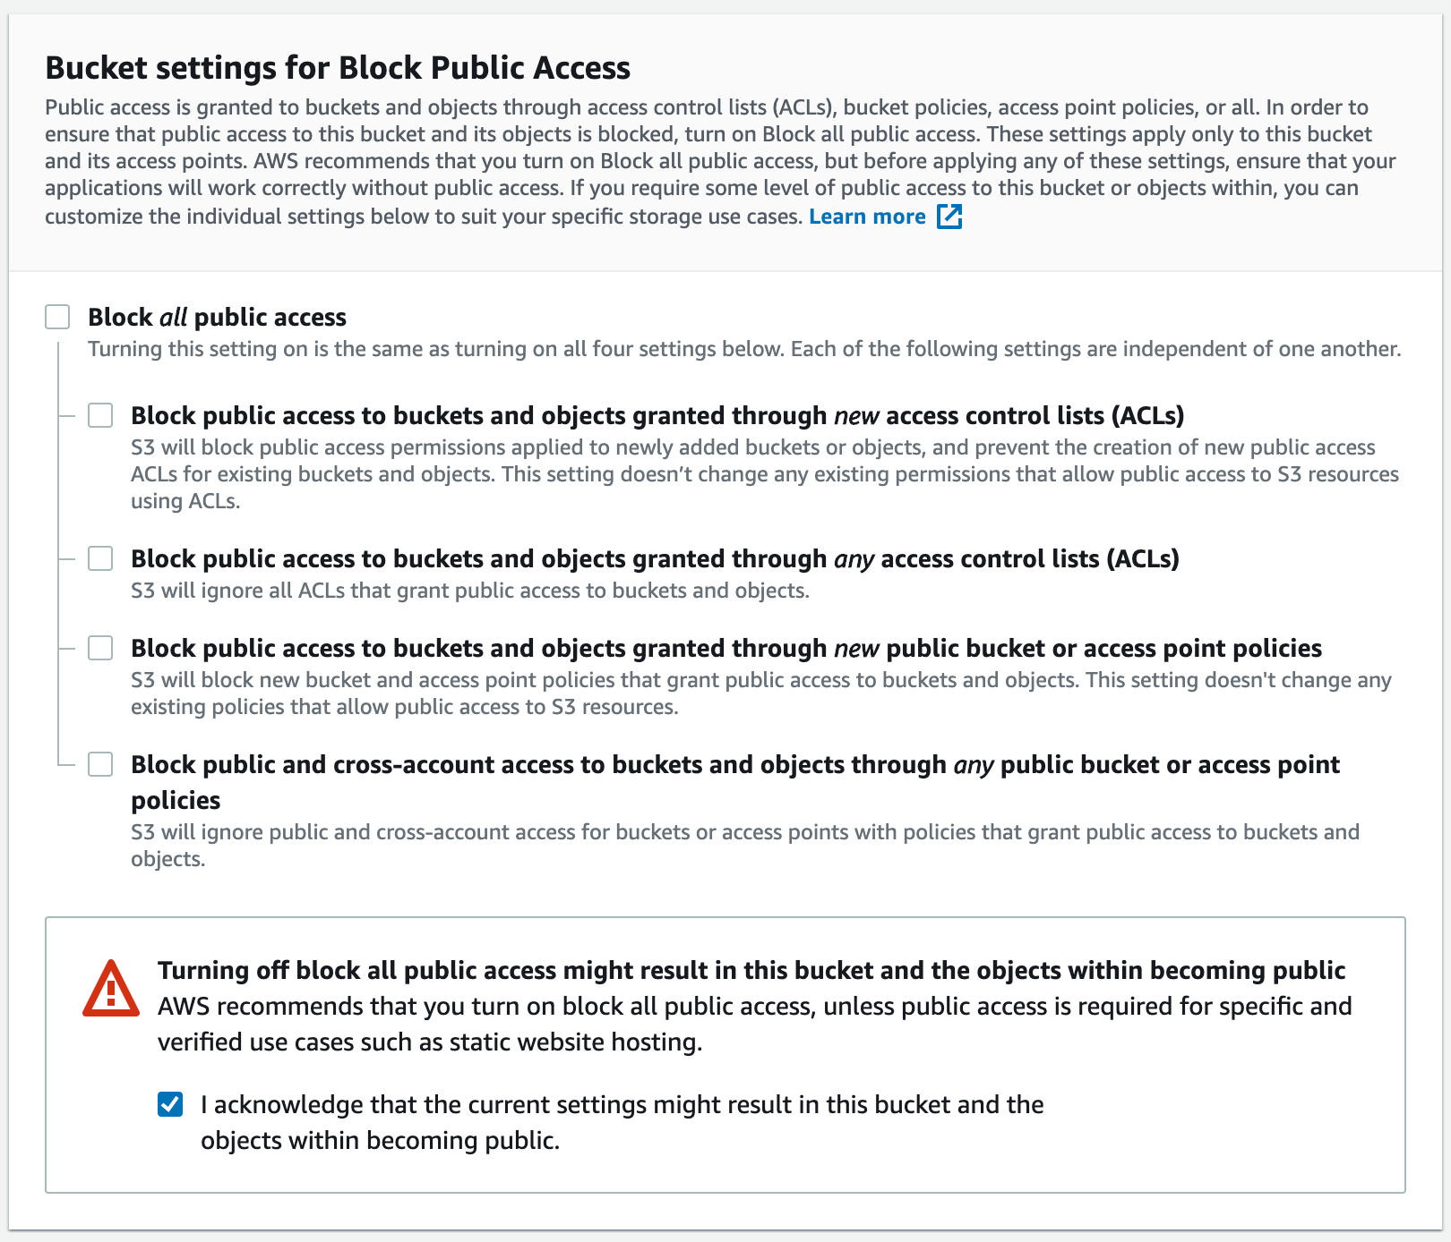
7. Keep everything default and click on Create bucket.button.

## Task 2: Enable Static Website Hosting

1. Click your S3 bucket name and navigate to the Properties tab at the top of the screen.
2. Scroll down to the Static website hosting and click Edit.
3. In the Static website hosting dialog box

* Static website hosting : Select Enable
* Hosting type : choose Host a static website
* Index document : Type *index.html*
* Error document : Type *error.html*
* Click on Save changes.

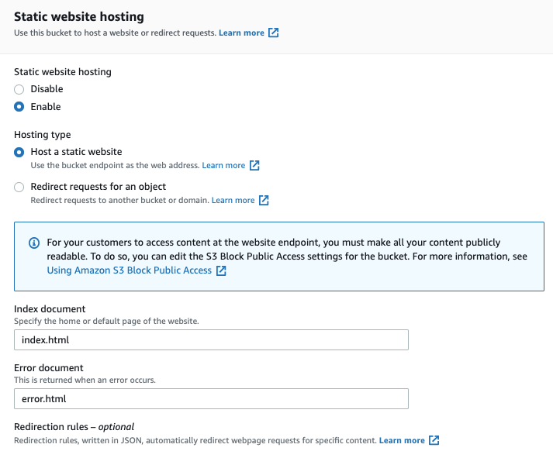

4. Copy the Endpoint from **P**roperties > Static website hosting to your clipboard and save it somewhere for later use.

* It will look similar to: http://bucketname.s3-website-us-east-1.amazonaws.com

5. Next, task_23.zip the zip file unzip and upload index.html and error.html to your s3 bucket.

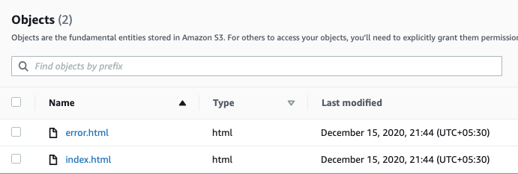

6. Click the Permissions tab to configure your bucket.

* In the Permissions tab, Click on the Edit button besides the Bucket Policy.
* You will be able to see a Blank policy editor.
* Before creating the policy, you will need to copy the ARN (Amazon Resource Name) of your bucket.
* Copy the ARN of your bucket to the clipboard. It is displayed at the top of the policy editor. it looks like ARN:“arn:aws:s3:::your-bucket-name".
* In the policy below, update the bucket ARN on the Resource key value and copy the policy code.

| {  "Id":"Policy1",  "Version":"2012-10-17",  "Statement":[  {  "Sid":"Stmt1",  "Action":[  "s3:GetObject"  ],  "Effect":"Allow",  "Resource":"replace-this-string-with-your-bucket-arn/*",  "Principal":"*"  }  ]  } |
| --- |

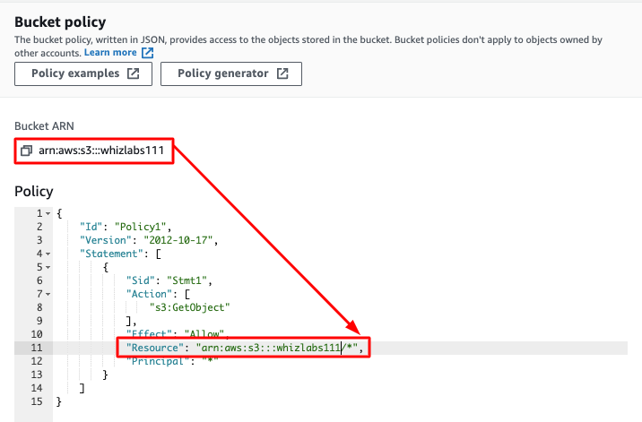

* Click on Save changes.



## Task 3: Test the website

1. Now copy the static website URL (that we saved earlier) and run it in your browser. You will be able to see the index.html file's text.

## Task 4: Test the website's error page

1. Copy the static website URL (which we saved earlier) , but this time, add some random characters to the end of the url to break it. When satisfied, hit enter. You will be redirected to the error.html page automatically.